
SATISH CHANDRA MEMORIAL SCHOOL
ACADEMIC SESSION: 2025-26
CLASS VII
CASE STUDY & ASSERTION-REASON QUESTION BANK
SEGMENT: MATHEMATICAL OPERATIONS
CHAPTER 02: FRACTIONS & DECIMALS
CASE STUDY 1
Riya, Tanaya and Sneha are 3 friends. Oneday, they had decided to have pizza at evening. So they had bought a pizza and divided it into 24 equal parts. Riya took $\frac{5}{24}$parts, Tanaya took $\frac{7}{24}$ parts and Sneha took $\frac{6}{24} parts$from it.
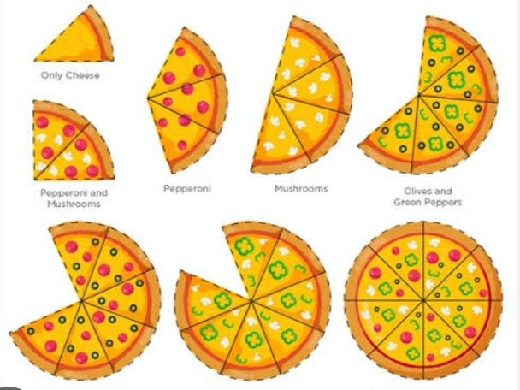
1. How many parts of the pizza are still left?
2. If Riya takes three more parts from the left then the total part of her is how much more than that of the parts of Sneha?
3. Who amongst them can’t take exactly the double part from the rest parts of pizza?
CASE STUDY 2
Water storage of Rohini’s house has a capacity of 1000 l. ( $\frac{1}{5})$^{th} of the water is consumed for kitchen.( $\frac{2}{5})$^{th}
of the water is used for bathing and washing clothes. Remaining water is used for watering plants in the garden of the house.
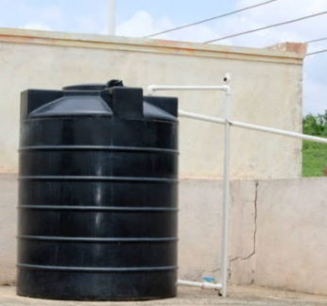
- How much water is used for bathing and washing clothes?
- How much water is used for watering the garden?
- What quantity of water is used for kitchen?
CASE STUDY 3
Ahana has gone for a trip with her parents in Assam during summer vacation. There they took a hotel which is 1.5 km away from Guwahati railway station. From their hotel river Brahmaputra is 250.7 km away from where they have to go 91.9 km to reach Majuli Island by boat. The distance between Majuli Island and their hotel is 342.6 km.
Oneday, they took a bus from their hotel and travelled 249.6 km and rest on foot to reach the river Brahmaputra. From there they took a ferry ride to Majuli Island.
At evening from Majuli Island they returned to their hotel by a car crossing a bridge which dropped them at a place 0.6 km away from their hotel, from where they returned on foot.

. How much km have they travelled by the car?
2. While reaching to the river Brahmaputra how much distance have they covered on foot?
3. If they ride from the river Brahmaputra to the Majuli island and again return to the shore by ferry, how much distance would they cover?

CASE STUDY 4
Mili has visited her uncle’s house at Cuttack for 10 days in summer vacation. Her uncle’s house is 176.25 km from Konark Sun Temple. There she went to visit Konark Sun Temple with her uncle and aunty covering half of of there journey by bus then 87.625 km by tempo and the rest on foot. While returning from there they covered one-third of their journey by tempo,117.25 km by bus and the rest on foot.
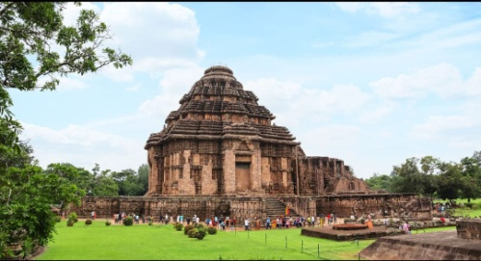

- How much distance did they cover on foot while going to the temple?
- Find the difference between the distance covered by them during the entire journey by tempo.
- Write the multiplicative inverse of the distance covered on foot while returning home.
- Subtract the distance covered by tempo while going from the sum of distance covered by bus throughout the journey.

CASE STUDY 5
324 students of class VII were surveyed on their favorite breakfast.

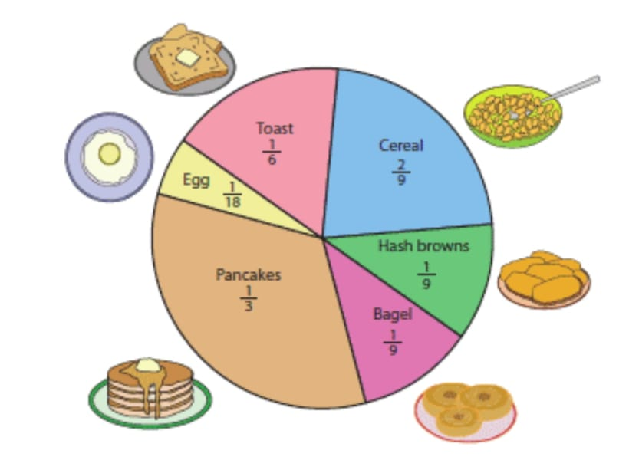
- How many students like pancakes?
- Find the total number of students who like Cereal, Egg and Toast.
- What is the additive inverse of the students like Bagel?
- Which one is greater: The number of students who like Hash browns or Pancakes and by how much?
- The number of students who like Toast is how much more than that of Egg?
CASE STUDY 6
During Diwali, Soumi planned to visit her hometown Durgapur. Her hometown is 245 km from Chakdaha. She reached Bardhaman by train covering three-fifth of her journey. Further, she travelled by bus and covered four-seventh km of the rest distance and then by taxi for one-twenty fifth km of the total journey. Finally, She took a toto for the rest distance to reach her hometown.
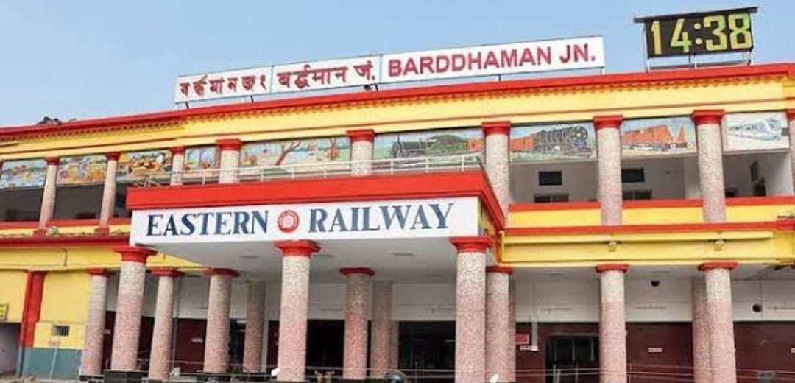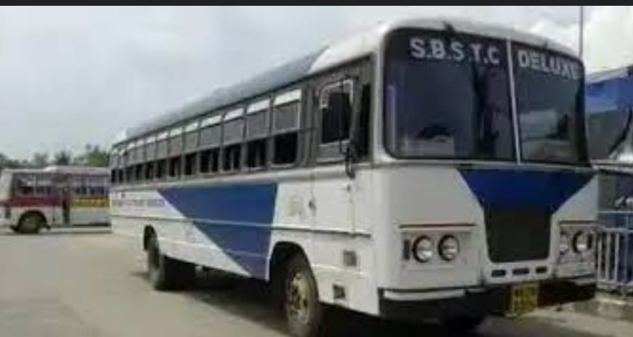
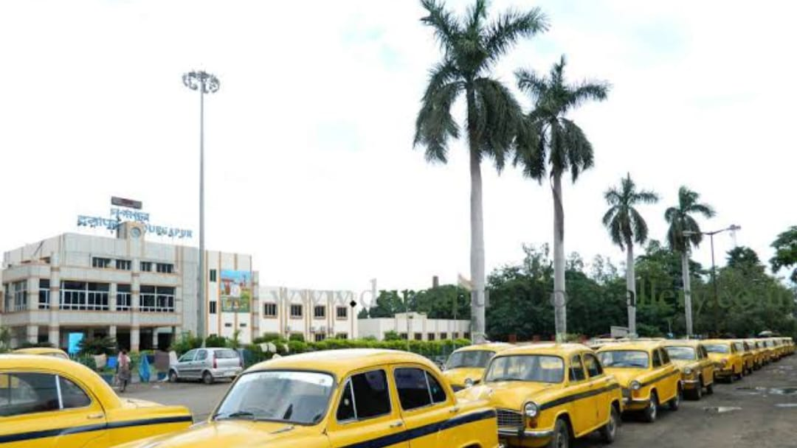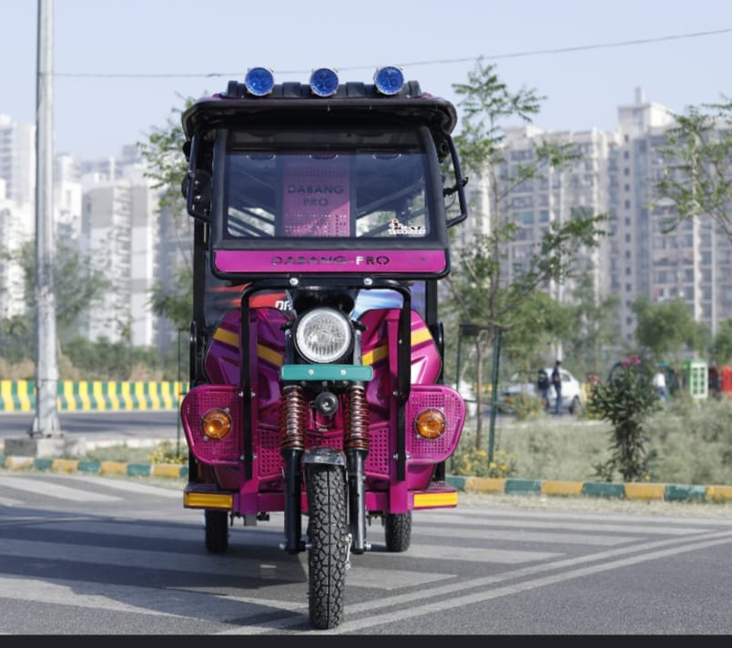

- Calculate the distance covered by Soumi by bus.
- How much distance has she covered on taxi?
- Find the distance travelled by her by toto.
$$Assertion-Reason Based Questions$$

$$INSTRUCTIONS: All the questions given below are Assertion and Reason based$$
$$questions. Two statements are given, one labelled as Assertion and$$
$$the other is labelled as Reason. Select the correct options from$$
$$the codes \left(a\right), \left(b\right), \left(c\right), \left(d\right)as given below.$$
$$\left(a\right) Both Assertion(A) and Reason(R) are correct and Reason(R) is the correct explanation$$
$$of Assertion(A).$$
$$\left(b\right) Both Assertion(A) and Reason(R) are correct but Reason(R) is not the correct explanation$$
$$of Assertion(A).$$
$$\left(c\right) Assertion(A) is true but Reason(R) is false.$$
$\left(d\right) Assertion(A) is false but Reason(R) is true.$

$1. Assertion(A):$The reciprocal of a non-zero fraction is obtained by interchanging its numerator and denominator.
$Reason(R):$The reciprocal$of$ $\frac{32}{29} is\frac{-29}{32}$
$2. Assertion\left(A\right)$ : $\frac{36.02}{100 } is a decimal fraction.$
$Reason(R):$The value of$\frac{36.02}{100 }$ is$0.3602$
$3 . Assertion\left(A\right): \frac{69}{10 }$ is a proper fraction.
$Reason\left(R\right):$In a proper fraction numerator is less than the denominator.

$4. Assertion\left(A\right):$The value of product of two proper fractions is always less than each of the fraction.
$$Reason\left(R\right): \frac{2}{3 } ×\frac{5}{7 }=\frac{10}{21 }$$

$5. Assertion(A):$The fractions where the denominator of each fraction is same is called the like fractions.
$Reason\left(R\right): \frac{32}{40 }and \frac{36}{40 } are unlike fractions.$

